Software Design Document (SDD)
Module:SPI Driver
Version: 1.0
Author: De La Torre Gomez Aldo Sebastian 37969, Cuadros Troncoso Pedro 37795, Garcia Veliz Oskar Liborio 38265

1. Introduction

1.1. Purpose
This document describes the software design and architecture of the SPI driver module developed for the STM32F411RE microcontroller, as part of the Microcontrollers and Embedded Systems course at CETYS Universidad. The design is based on the requirements defined in SRS-SPI_Driver v1.0 and provides details on data structures, enumerations, register-level algorithms, and control flow to guide implementation and testing. This SDD also serves as a reference for maintenance, testing, and future improvements of the SPI driver firmware.

1.2. Scope
The SPI driver is a low-level software component for embedded systems. It abstracts STM32 hardware SPI registers (CR1, CR2, SR, DR) and provides a clean C API for higher-level modules such as sensor drivers. The system performs the following specific operations:
- Configures SPI1 in Master Mode, Mode 0 (CPOL=0, CPHA=0), 8-bit data frame, MSB first, fPCLK/8 (~2 MHz) using PA5 (SCK), PA6 (MISO), PA7 (MOSI) with Alternate Function 5 (AF5), and PA4 as software-managed CS.
- Provides spi_transmit() to send multiple bytes polling TXE/RXNE in full-duplex; received bytes are discarded.
- Provides spi_receive() to receive multiple bytes by sending dummy bytes (0x00) over MOSI to generate the clock, capturing MISO data.
- Provides spi_csEnable() and spi_csDisable() for software chip select control via gpio_clearPin() and gpio_setPin() on PA4.
- Validates buffer pointers (non-NULL) and length (>0) before any hardware access, returning SPI_Status_t error codes (NFR-2).
- Does not depend on HAL or LL libraries — all hardware interaction uses direct MCU register access through CMSIS SPI_TypeDef and RCC_TypeDef.

1.3. Definitions, Acronyms, and Abbreviations

Term | Definition
SPI | Serial Peripheral Interface — synchronous four-wire serial protocol.
SCK | Serial Clock — driven by the master to synchronize data transfer.
MOSI | Master Out Slave In — data driven from master to slave.
MISO | Master In Slave Out — data driven from slave to master.
CS | Chip Select — active-low signal that selects the target SPI device.
CR1 | Control Register 1 — SPE, BR, MSTR, CPOL, CPHA, SSM, SSI, LSBFIRST, DFF bits.
CR2 | Control Register 2 — DMA, interrupt, SSOE enables. Set to 0 (manual CS).
SR | Status Register — TXE, RXNE, BSY, OVR, MODF, CRCERR flags.
DR | Data Register — write: byte shifted out on MOSI; read: byte received on MISO.
TXE | Transmit Buffer Empty — set when DR can accept a new byte.
RXNE | Receive Buffer Not Empty — set when DR holds a received byte.
BSY | Busy flag — set while SPI is transferring or TX buffer not empty.
OVR | Overrun Error — set when RXNE was not cleared before next byte arrived.
MODF | Mode Fault — set when NSS pulled low in master mode.
CRCERR | CRC Error — received CRC does not match (CRC disabled in this driver).
SPE | SPI Enable bit in CR1 — enables the SPI peripheral.
SSM | Software Slave Management — when set, NSS is managed by SSI bit (not hardware).
SSI | Internal Slave Select — must be HIGH in master mode to prevent spurious MODF.
BR | Baud Rate bits [5:3] in CR1 — fPCLK/2^(BR+1); BR=010 -> fPCLK/8.
FR-x | Functional Requirement x — defined in SRS-SPI_Driver v1.0.
NFR-x | Non-Functional Requirement x — defined in SRS-SPI_Driver v1.0.
HAL | Hardware Abstraction Layer — NOT used; driver uses direct register access.
CMSIS | Cortex Microcontroller Software Interface Standard.

1.4. Requirements
All requirements for this module are allocated in SRS-SPI_Driver v1.0. This document covers FR-1 through FR-8 (functional) and NFR-1 through NFR-3 (non-functional).

Req. ID | Type | Description
FR-1 | Functional | spi_init() shall configure the SPI1 peripheral to a default state: Master Mode, Mode 0, 8-bit, MSB first, SSM=1/SSI=1, fPCLK/8.
FR-2 | Functional | spi_init() shall enable clocking for GPIOA (AHB1ENR) and SPI1 (APB2ENR) before any register access.
FR-3 | Functional | spi_transmit() shall send multiple bytes from a data buffer polling TXE before each write and RXNE after to maintain full-duplex synchronization.
FR-4 | Functional | spi_transmit() shall ensure proper synchronization with the SPI clock by using the prv_transfer_byte() full-duplex exchange primitive.
FR-5 | Functional | spi_receive() shall read multiple bytes into a data buffer by sending dummy bytes (0x00) to drive the SPI clock.
FR-6 | Functional | spi_receive() shall ensure proper synchronization with the SPI clock using the same prv_transfer_byte() primitive as spi_transmit().
FR-7 | Functional | spi_csEnable() shall drive the CS line LOW via gpio_clearPin() to select the target SPI device.
FR-8 | Functional | spi_csDisable() shall drive the CS line HIGH via gpio_setPin() after waiting for SR.BSY to clear, ensuring the last byte is fully shifted out.
NFR-1 | Non-Functional | The driver shall be lightweight and efficient: direct register access, no HAL/LL dependency.
NFR-2 | Non-Functional | The driver shall validate buffer pointers (non-NULL) and length (>0) before any hardware access, returning SPI_Status_t on failure.
NFR-3 | Non-Functional | All flag-polling loops shall include SPI_TIMEOUT (160000 cycles, ~10 ms); no operation blocks indefinitely.

2. System Architecture

2.1. High-Level Design
- Layered Architecture:
- Application Layer: main.c calls adxl345_driver API. Never accesses SPI registers directly.
- Sensor Driver Layer: adxl345_driver.c uses SPI driver public API exclusively — spi_csEnable(), spi_transmit(), spi_receive(), spi_csDisable().
- SPI Driver Layer: spi_driver.c — the only layer accessing SPI1 registers (CR1, CR2, SR, DR) and RCC.
- Hardware Layer: STM32F411RE SPI1 peripheral and RCC via CMSIS. Not visible above SPI driver.

2.2. Module Interfaces
- Public API: spi_init(), spi_transmit(), spi_receive(), spi_csEnable(), spi_csDisable() — declared in spi_driver.h.
- Dependencies: stm32f4xx.h, gpio_driver.h, stdint.h, stddef.h. No HAL/LL (NFR-1).
- Internal Functions: prv_wait_sr(), prv_has_error(), prv_check_bus(), prv_transfer_byte() — static in spi_driver.c, not exposed in public API.

3. Detailed Design

3.1. Module Description

A. SPI Driver Module (spi_driver.c / spi_driver.h)
Responsible for all direct register access to the STM32F411RE SPI1 peripheral. Provides hardware abstraction for bus initialization, full-duplex byte exchange, multi-byte transmission (with MISO discarded), multi-byte reception (with dummy MOSI bytes), and software CS control. prv_transfer_byte() is the core primitive used by both spi_transmit() and spi_receive().

B. ADXL345 Sensor Driver (adxl345_driver.c / adxl345_driver.h)
Uses SPI driver public API exclusively. A typical ADXL345 SPI transaction: spi_csEnable() -> spi_transmit(cmd, 1) -> spi_receive(data, n) -> spi_csDisable(). adxl345_readData() performs a 7-byte SPI read (1 command + 6 data bytes) from DATAX0 and converts to milli-g using 3.9 mg/LSB.

C. Main Application (main.c)
Startup: serial_init() -> adxl345_init() -> infinite loop: adxl345_readData() + serial_printf() at 10 Hz. Never accesses SPI registers directly.

Fig. 1 — Class Diagram: SPI Driver Module
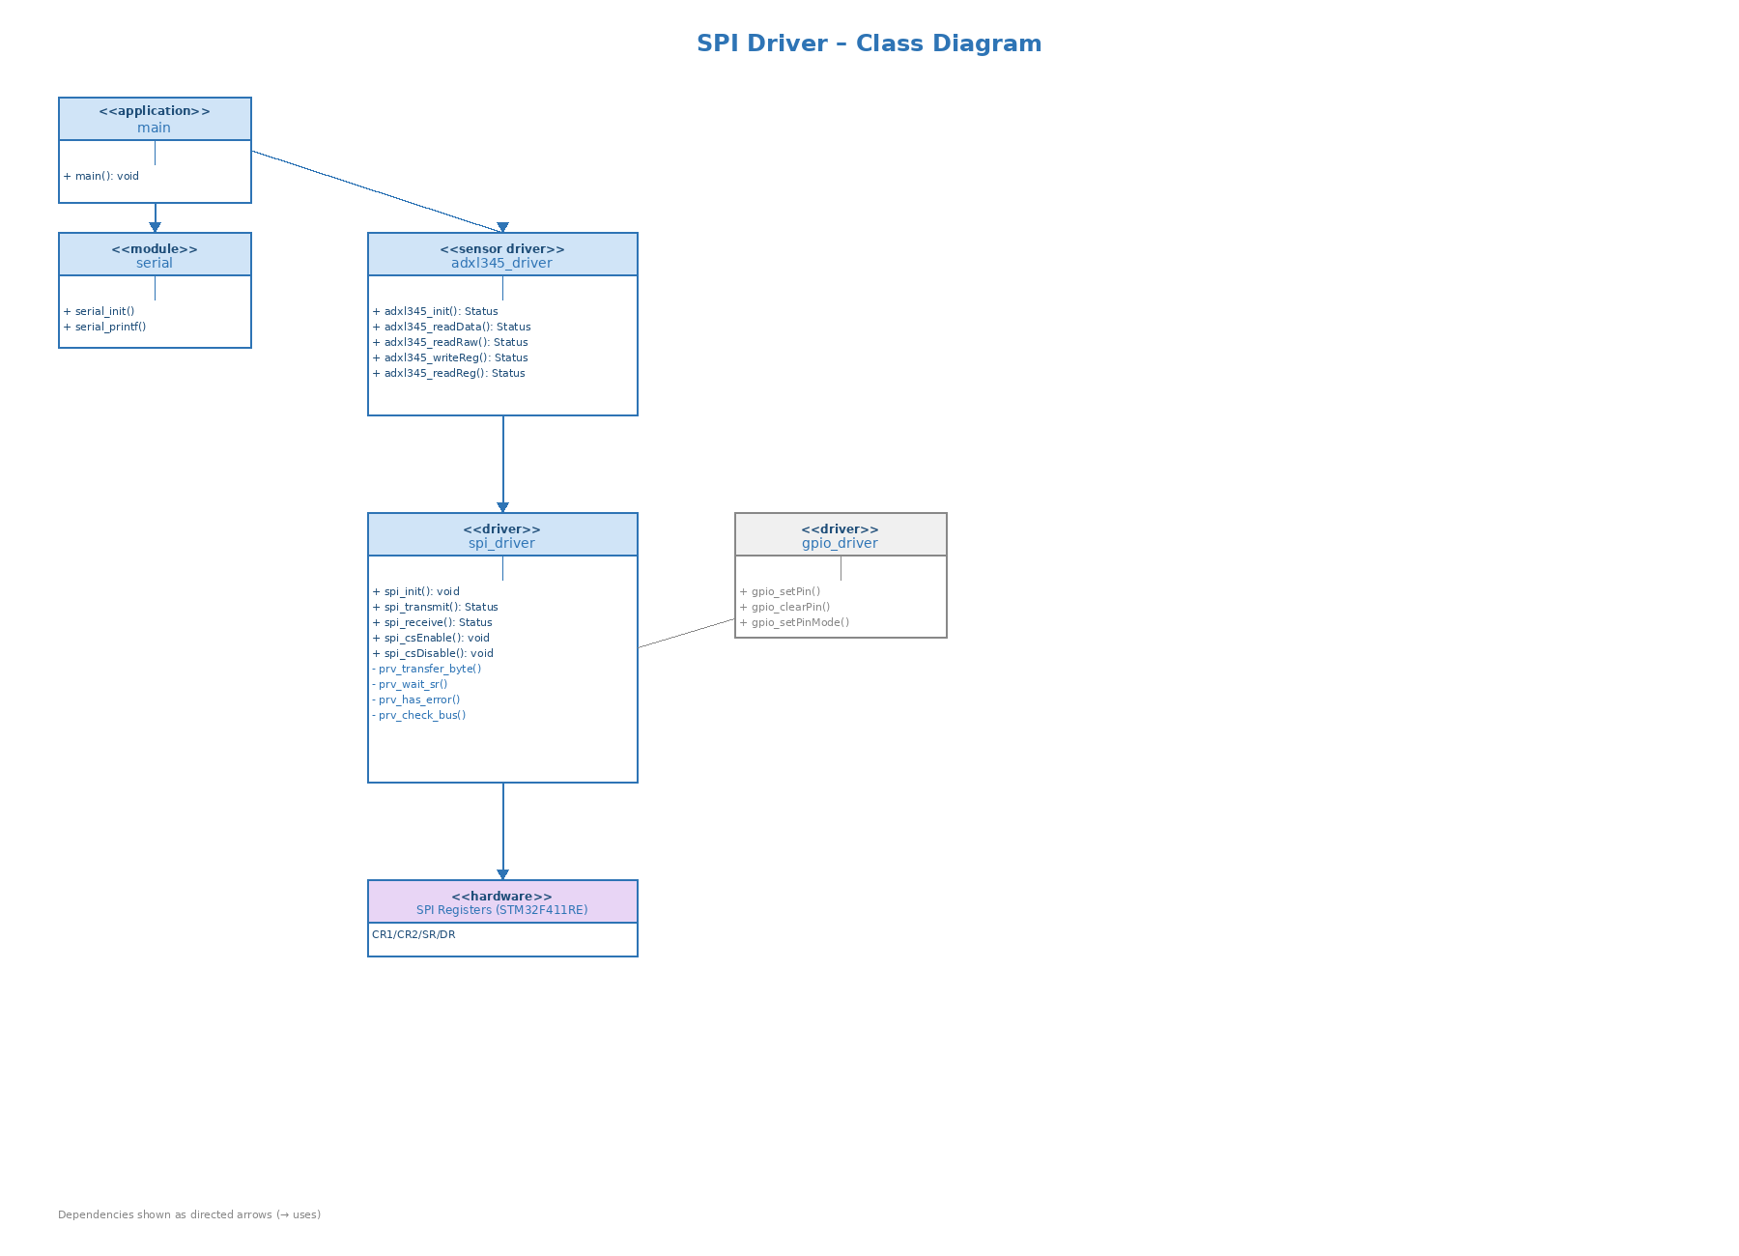
As shown in Fig. 1, main.c depends on adxl345_driver and serial. adxl345_driver depends exclusively on spi_driver. spi_driver is the only class accessing SPI1 hardware. Private helpers (minus prefix) are internal to spi_driver.c.

3.2. Module Behavior

Initial State
After spi_init(): SPI1 in Master Mode, Mode 0, 8-bit MSB-first at ~2 MHz. PA5/PA6/PA7 configured as AF5 push-pull. PA4 (CS) is HIGH (device deselected). SPE=1, SSM=1, SSI=1, MSTR=1, BR=010. No transaction in progress.

Event: Transmit Transaction
Caller: spi_csEnable() -> spi_transmit(data, len) -> spi_csDisable(). Inside spi_transmit(): prv_check_bus() confirms BSY=0. For each byte: prv_wait_sr(TXE) -> write DR (starts SCK) -> prv_wait_sr(RXNE) -> read DR (discard). prv_has_error() checks OVR/MODF/CRCERR after each byte.

Event: Receive Transaction
Caller: spi_csEnable() -> spi_receive(buf, len) -> spi_csDisable(). Inside spi_receive(): prv_check_bus() confirms BSY=0. For each byte: prv_wait_sr(TXE) -> write 0x00 to DR (drives SCK) -> prv_wait_sr(RXNE) -> read DR into buf[i].

Fig. 2 — Sequence Diagram: SPI Driver Initialization
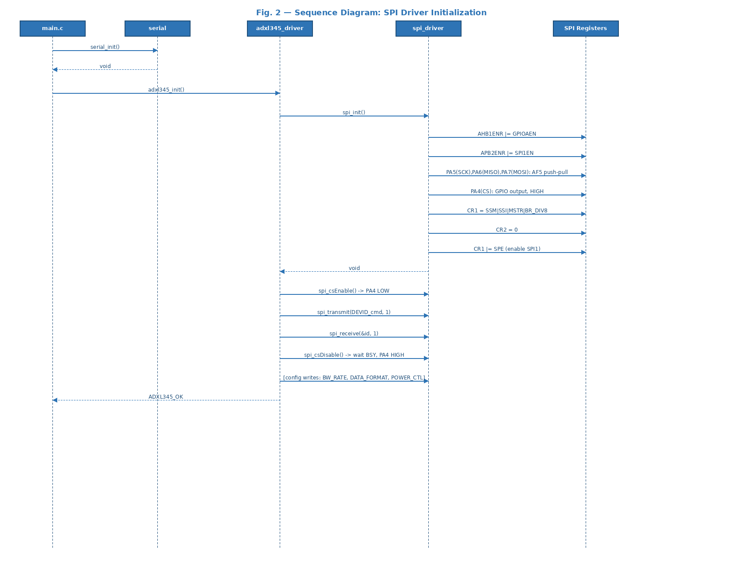
Fig. 2: main.c calls serial_init() then adxl345_init(). adxl345_init() calls spi_init() (the only hardware configuration call), then performs CS+transmit+receive cycles to verify DEVID and configure BW_RATE, DATA_FORMAT, POWER_CTL.

Fig. 3 — Activity Diagram: spi_init() [FR-1, FR-2]
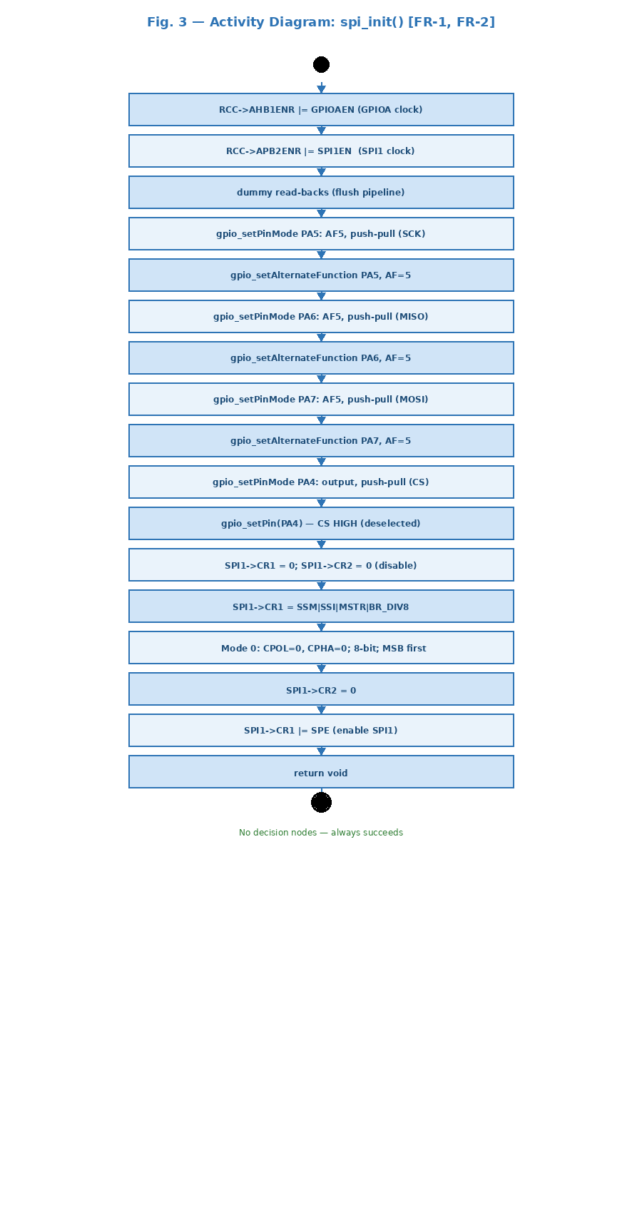
Fig. 3: Linear 17-step sequence — enable RCC clocks, configure AF5 pins, set CS HIGH, configure CR1/CR2, enable SPE. No decision nodes — always succeeds.

Fig. 4 — Sequence Diagram: spi_transmit() [FR-3, FR-4]
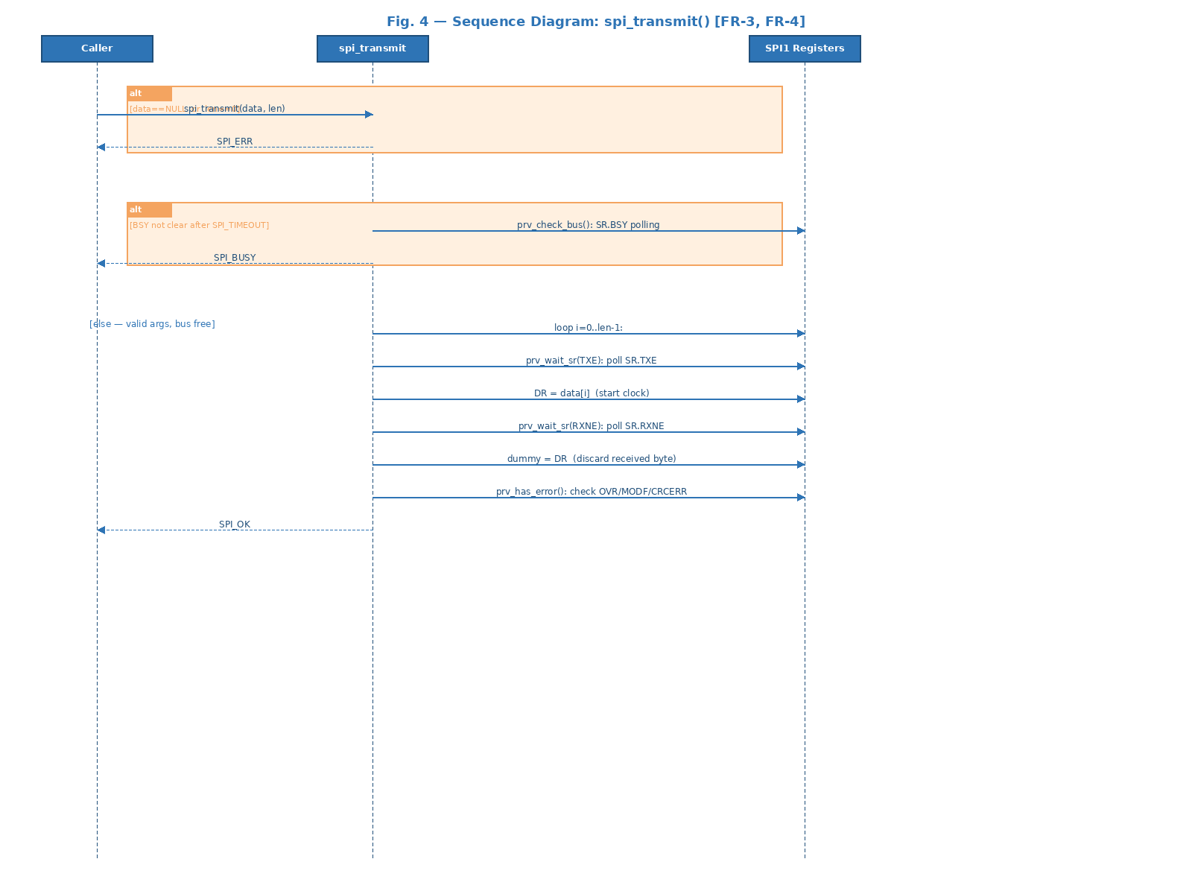
Fig. 4: Alt fragment for invalid args returns SPI_ERR. Alt for BSY timeout returns SPI_BUSY. Normal path: loop over bytes — TXE wait, DR write, RXNE wait, discard DR, error check.

Fig. 5 — Activity Diagram: spi_transmit() [FR-3, FR-4]
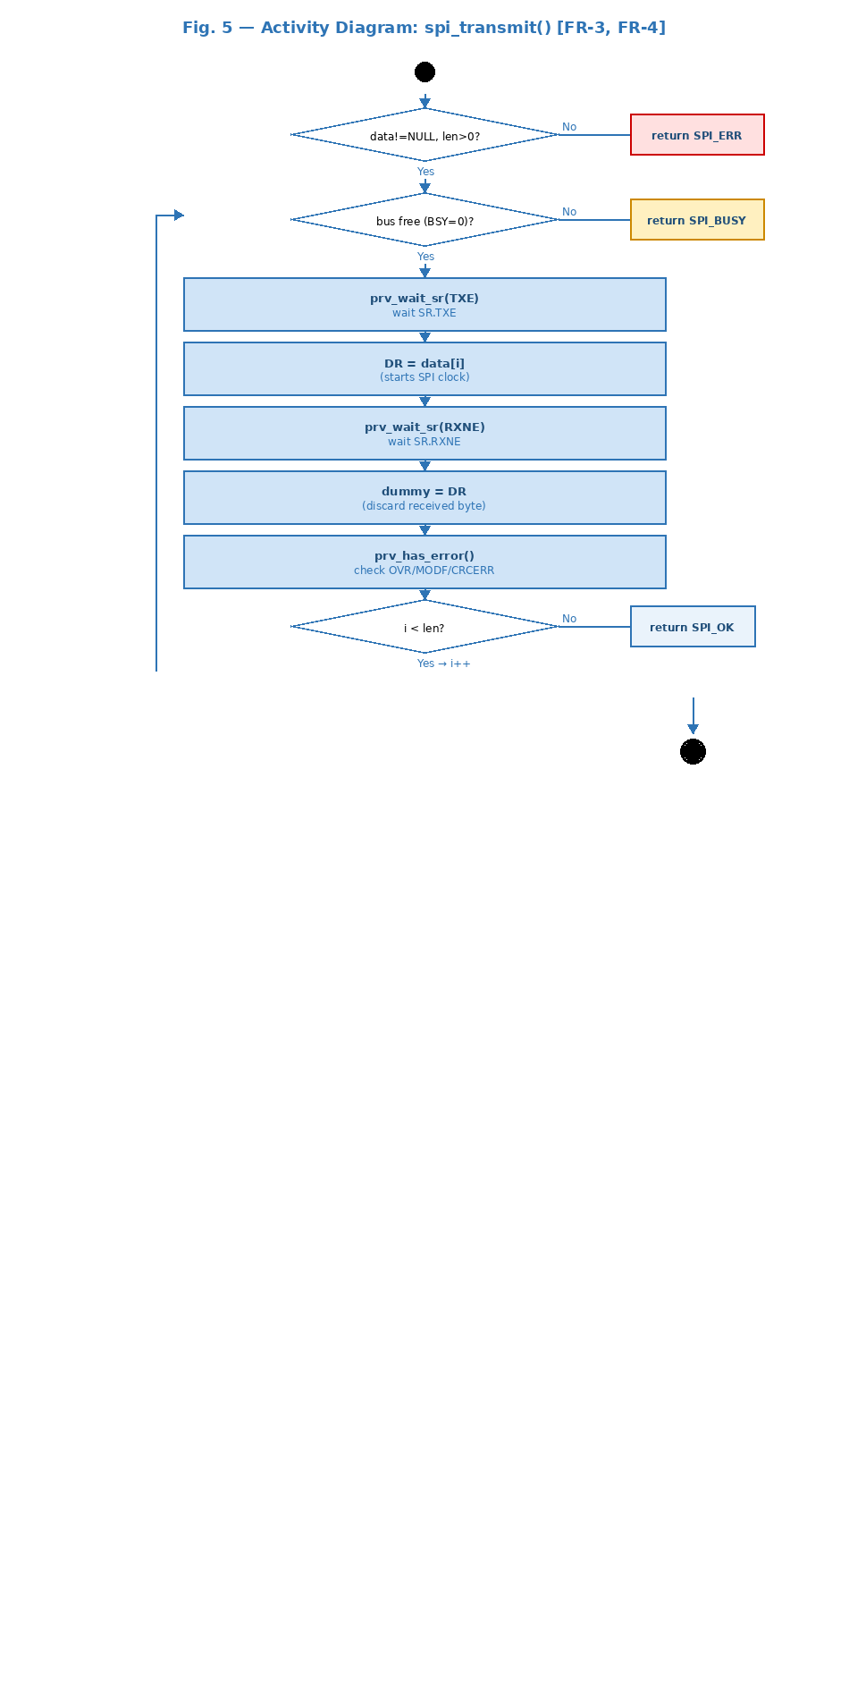
Fig. 5: Two decision nodes (args valid?, bus free?) then the byte-exchange loop. Loop decision [i<len?] drives back-arrow. No branch exits without returning SPI_OK or SPI_ERR/SPI_BUSY.

Fig. 6 — Sequence Diagram: spi_receive() [FR-5, FR-6]
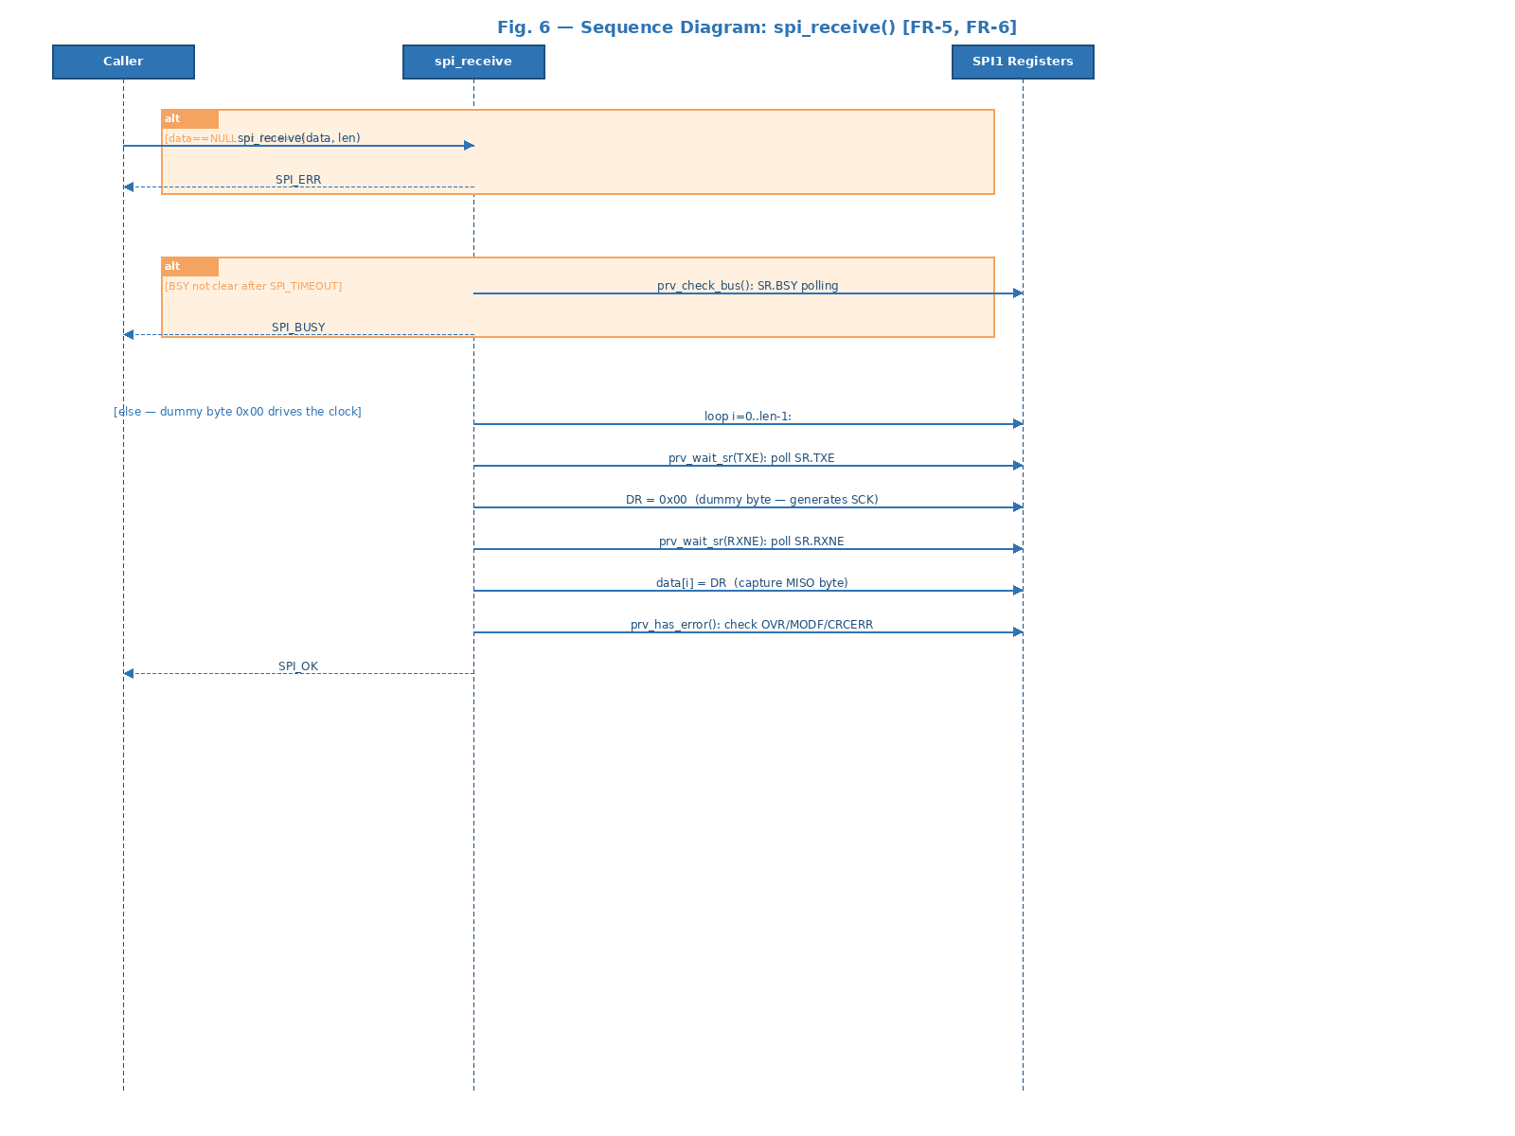
Fig. 6: Identical structure to spi_transmit(). Key difference: DR is written with 0x00 (dummy byte to drive SCK) and the received byte is stored in data[i] instead of discarded.

Fig. 7 — Activity Diagram: spi_receive() [FR-5, FR-6]
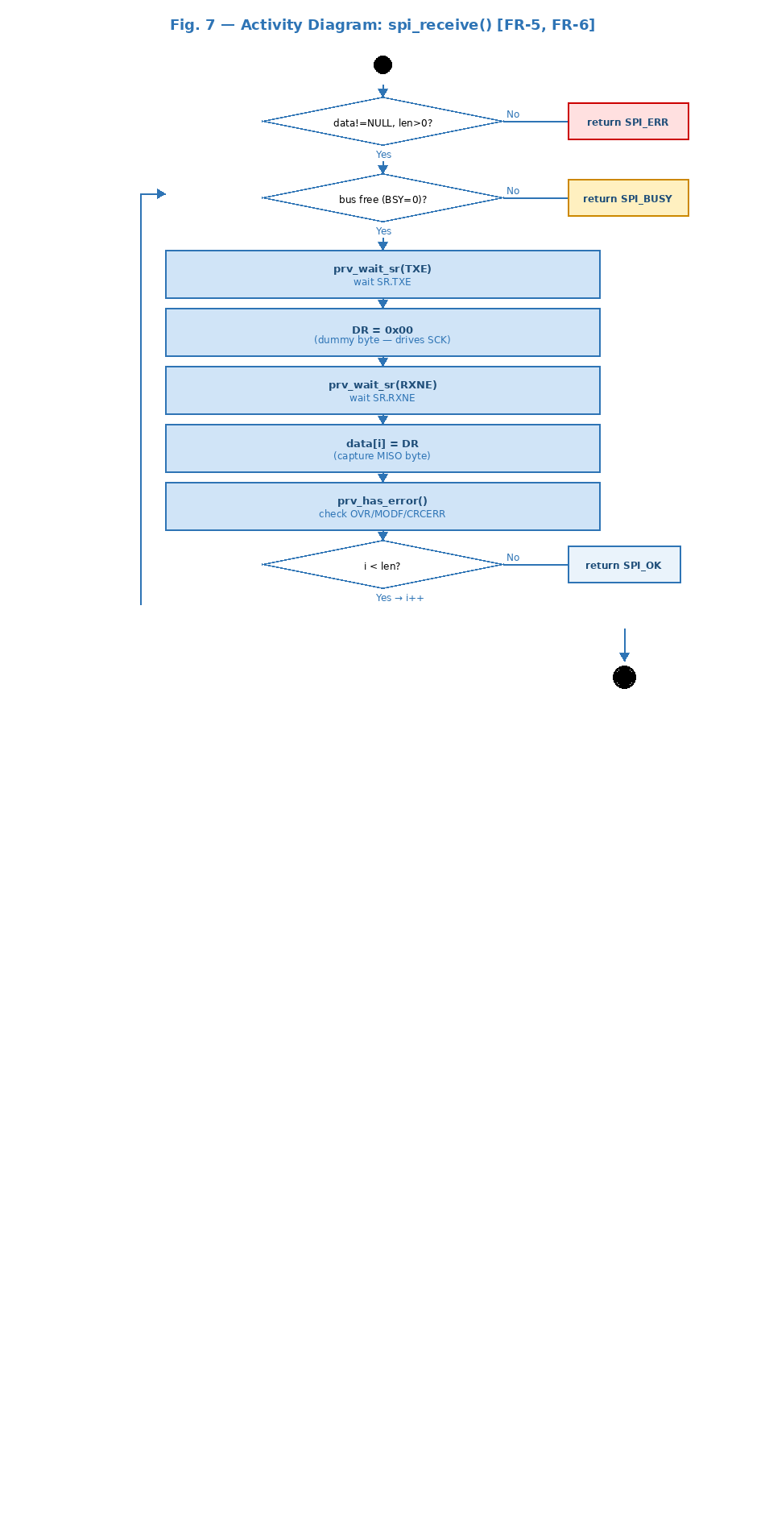
Fig. 7: Same flow as spi_transmit() activity diagram. The only difference is data[i]=DR instead of dummy=DR.

Fig. 8 — Sequence Diagram: spi_csEnable() / spi_csDisable() [FR-7, FR-8]
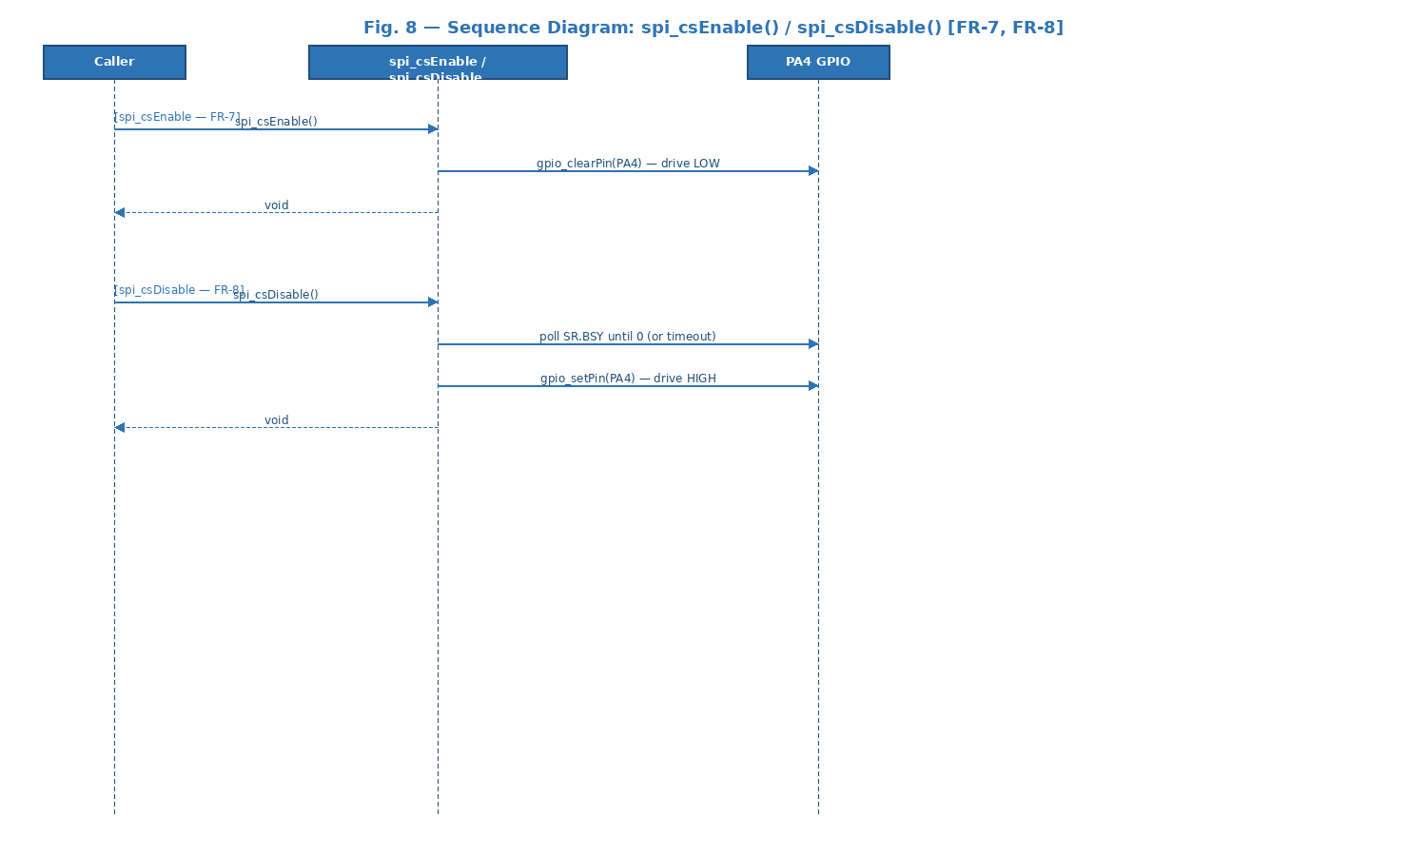
Fig. 8: spi_csEnable() is a single gpio_clearPin() call. spi_csDisable() polls SR.BSY until 0 (ensuring last bit shifted out) then calls gpio_setPin().

Fig. 9 — Activity Diagram: spi_csEnable() / spi_csDisable() [FR-7, FR-8]
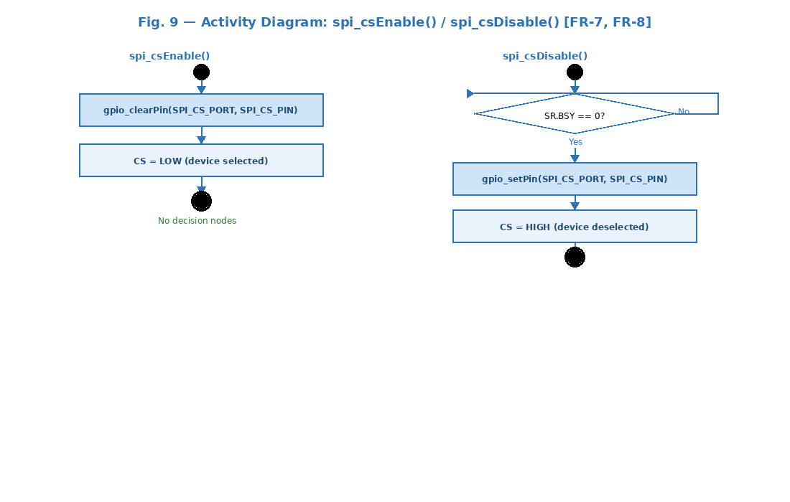
Fig. 9: csEnable (left) is a linear sequence with no decision nodes. csDisable (right) has a BSY polling loop before setting CS HIGH.

Fig. 10 — State Diagram: SPI Driver
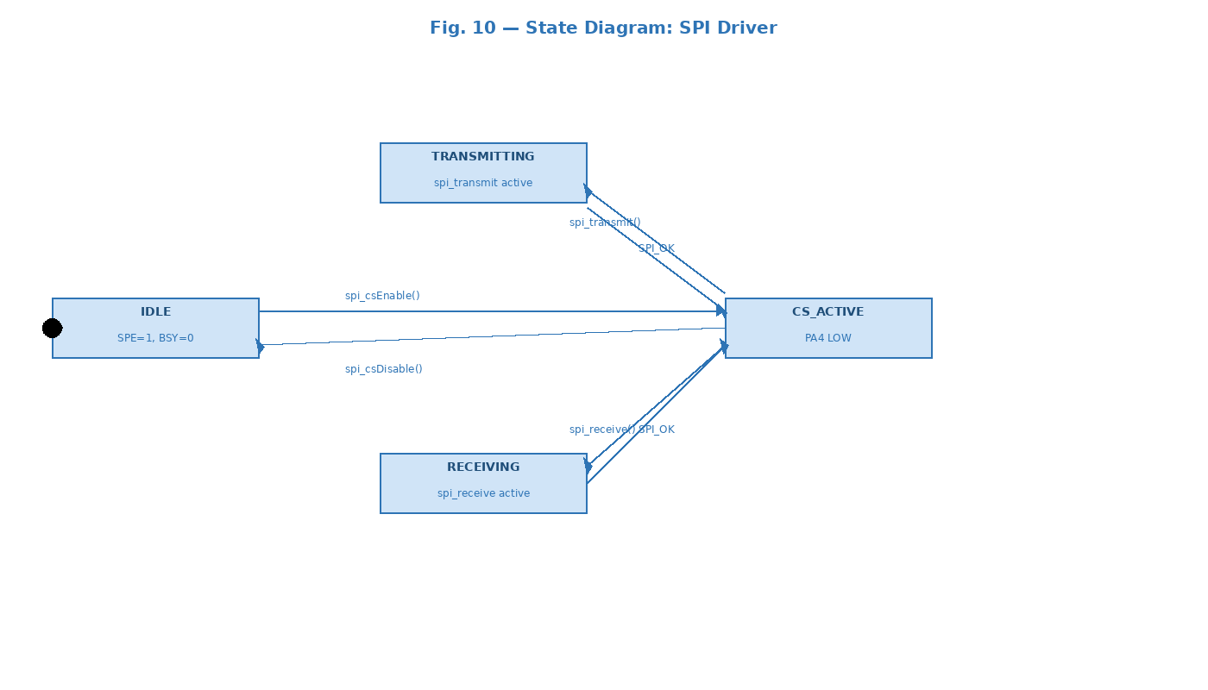
Fig. 10: IDLE -> CS_ACTIVE on spi_csEnable(). CS_ACTIVE -> TRANSMITTING on spi_transmit(). CS_ACTIVE -> RECEIVING on spi_receive(). Both return to CS_ACTIVE on SPI_OK. CS_ACTIVE -> IDLE on spi_csDisable() (after BSY=0).

3.2.1. Per-Function Sequence and Activity Diagrams

spi_init() — FR-1, FR-2: SPI Subsystem Initialization
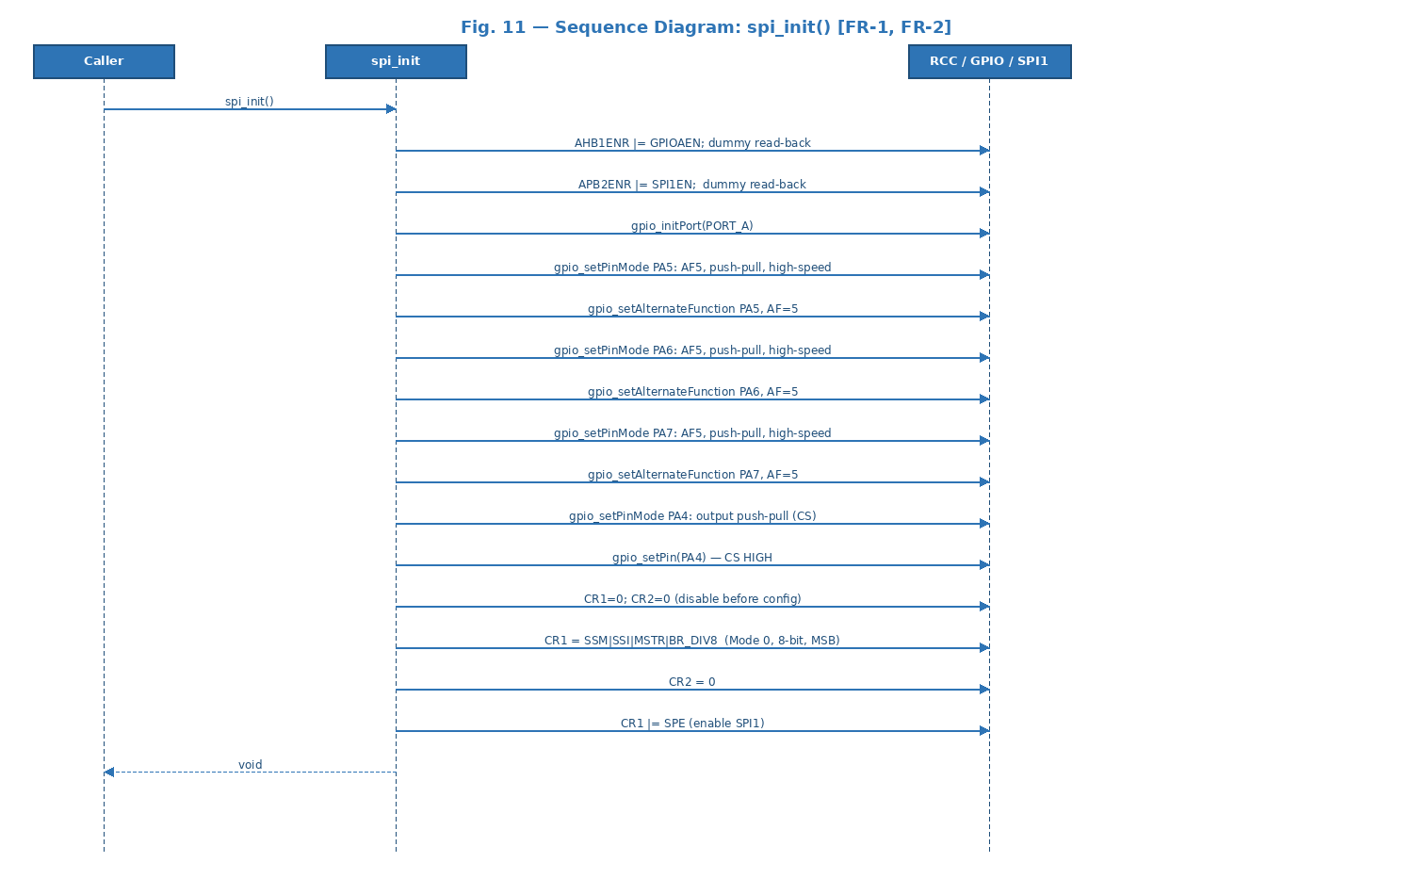
Fig. 11 — Sequence Diagram: 15 register writes/configurations. Returns void — always succeeds.
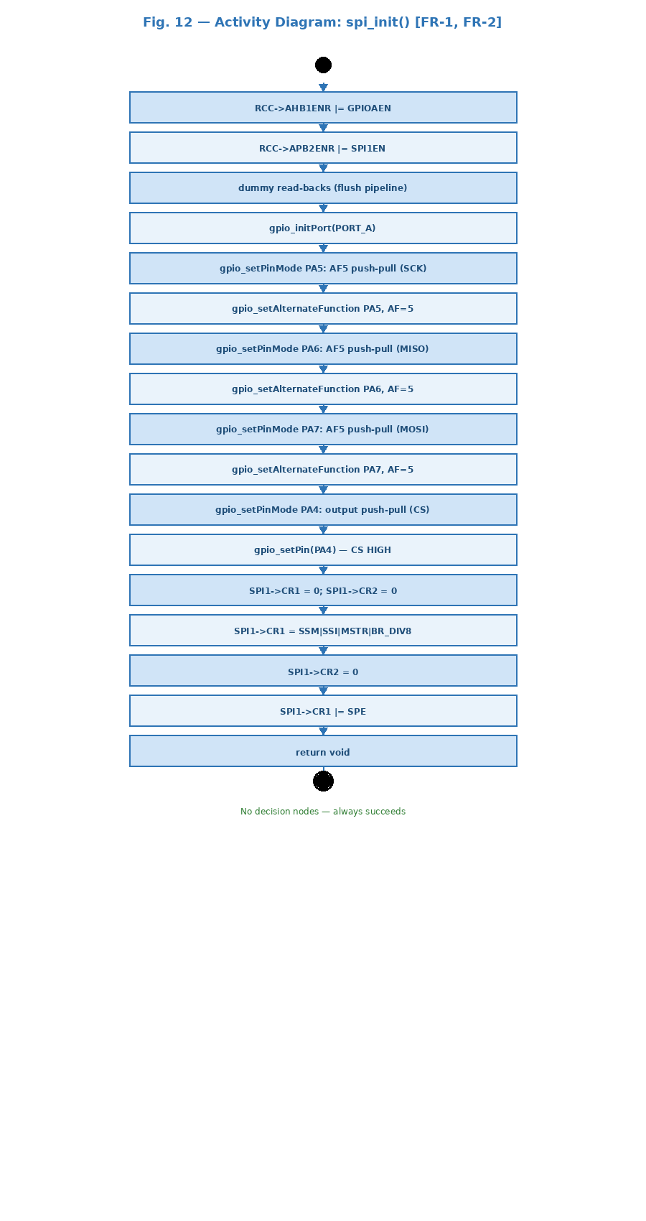
Fig. 12 — Activity Diagram: 17-step linear sequence. No decision nodes.

spi_transmit() — FR-3, FR-4: Multi-byte Transmit
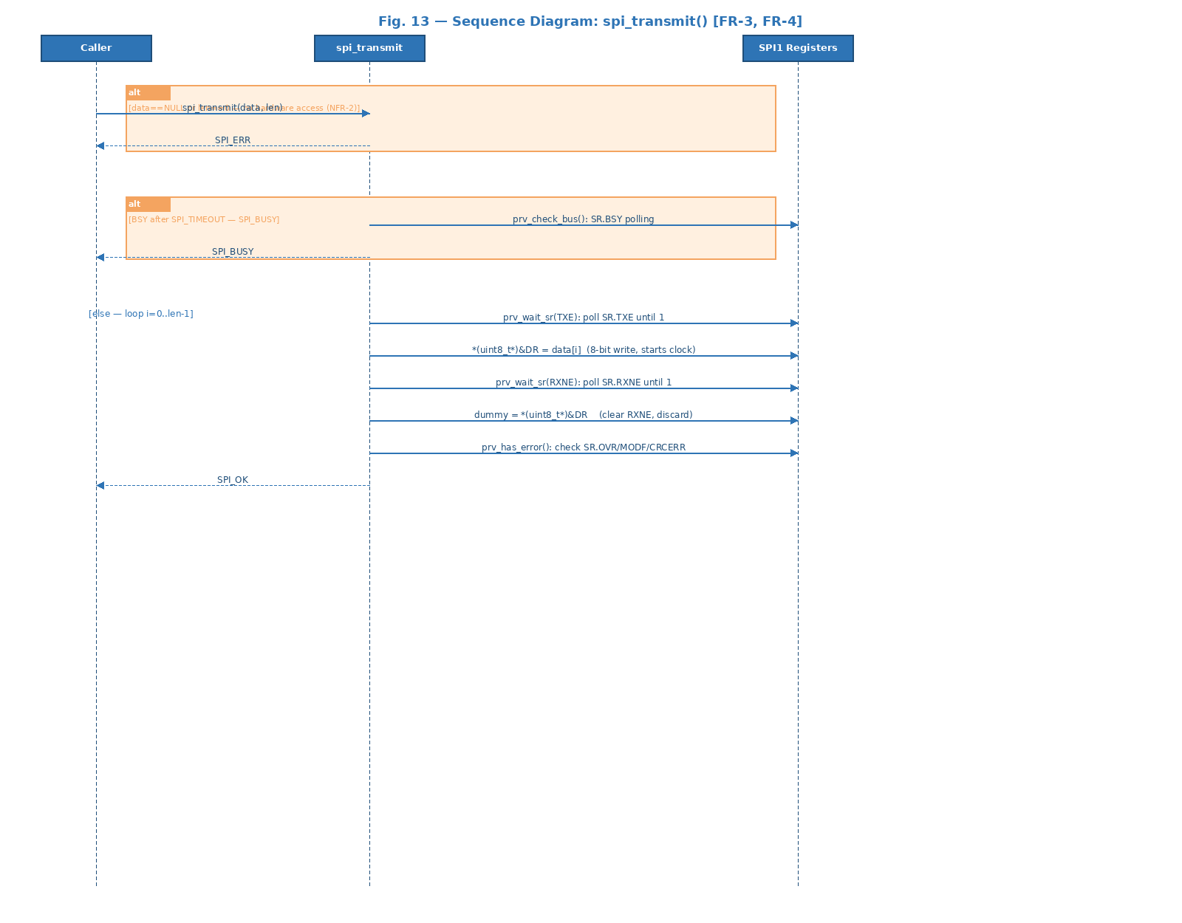
Fig. 13 — Sequence Diagram: Two alt fragments for early exit, then the full-duplex byte loop using 8-bit DR access.
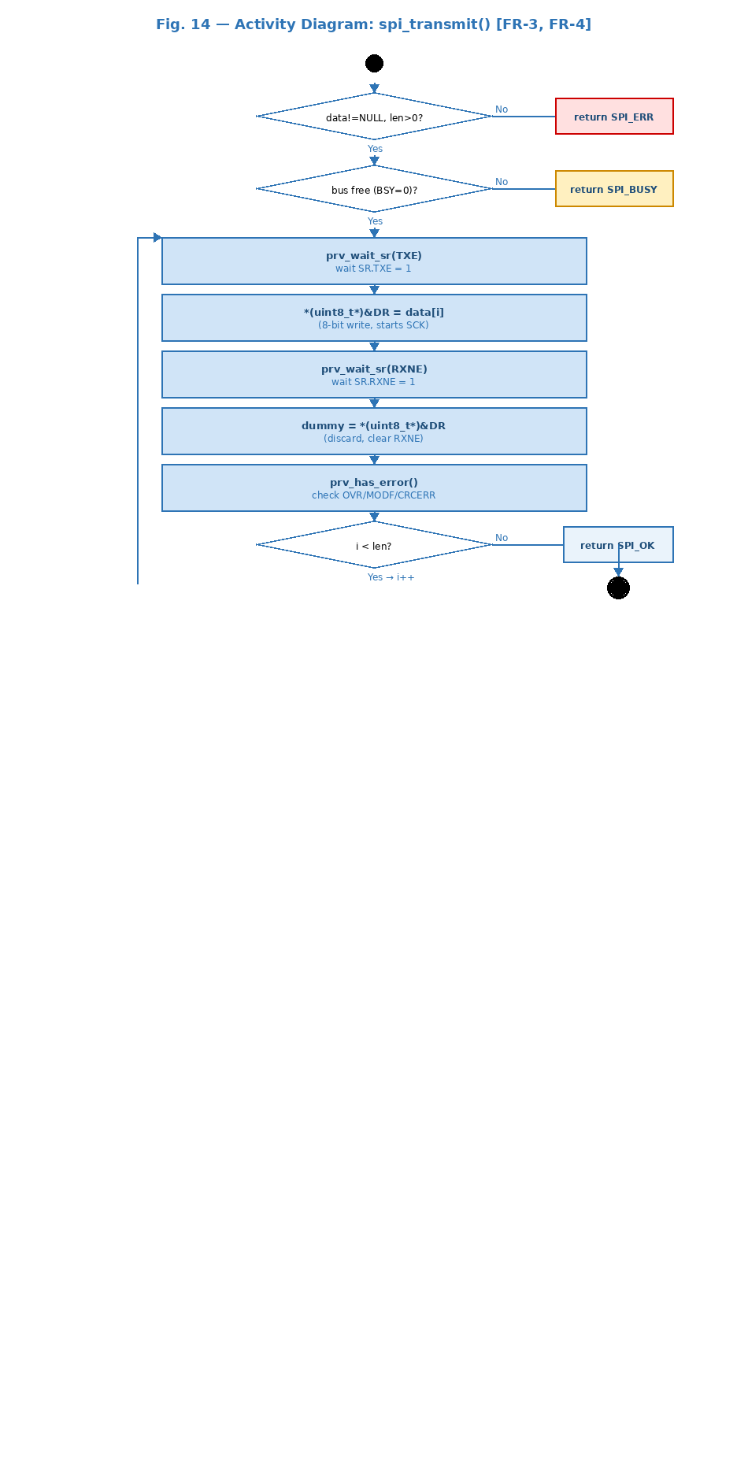
Fig. 14 — Activity Diagram: Two validation diamonds, then TXE->write->RXNE->discard loop with back-arrow for i<len.

spi_receive() — FR-5, FR-6: Multi-byte Receive
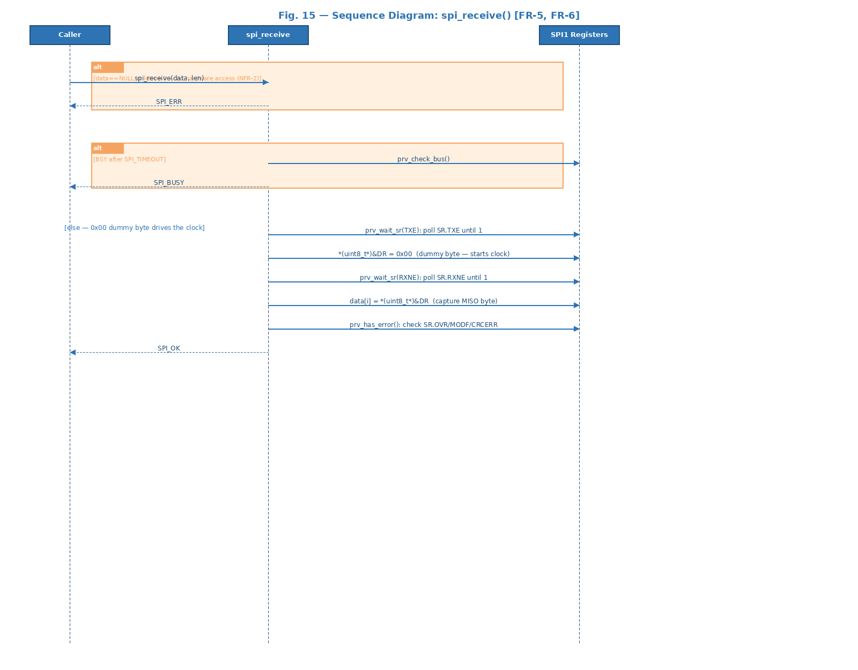
Fig. 15 — Sequence Diagram: Same as spi_transmit() but DR written with 0x00 and received byte stored in data[i].
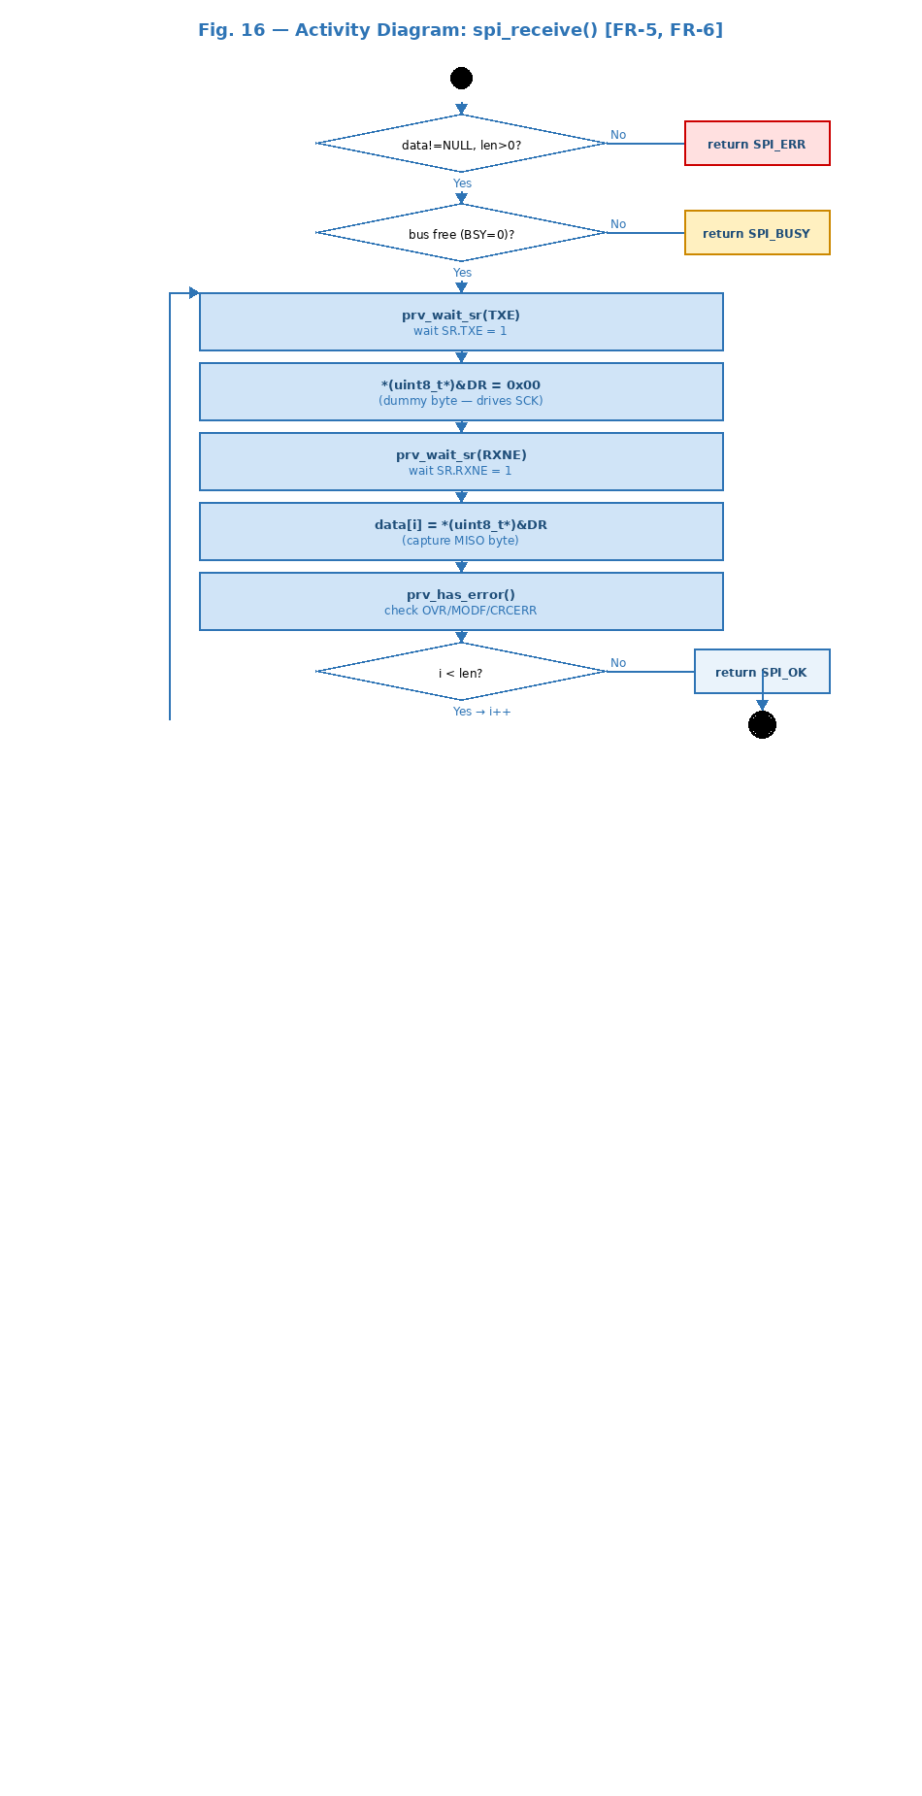
Fig. 16 — Activity Diagram: Symmetric to spi_transmit() activity. data[i]=DR captures the MISO byte.

spi_csEnable() / spi_csDisable() — FR-7, FR-8: Chip Select Control
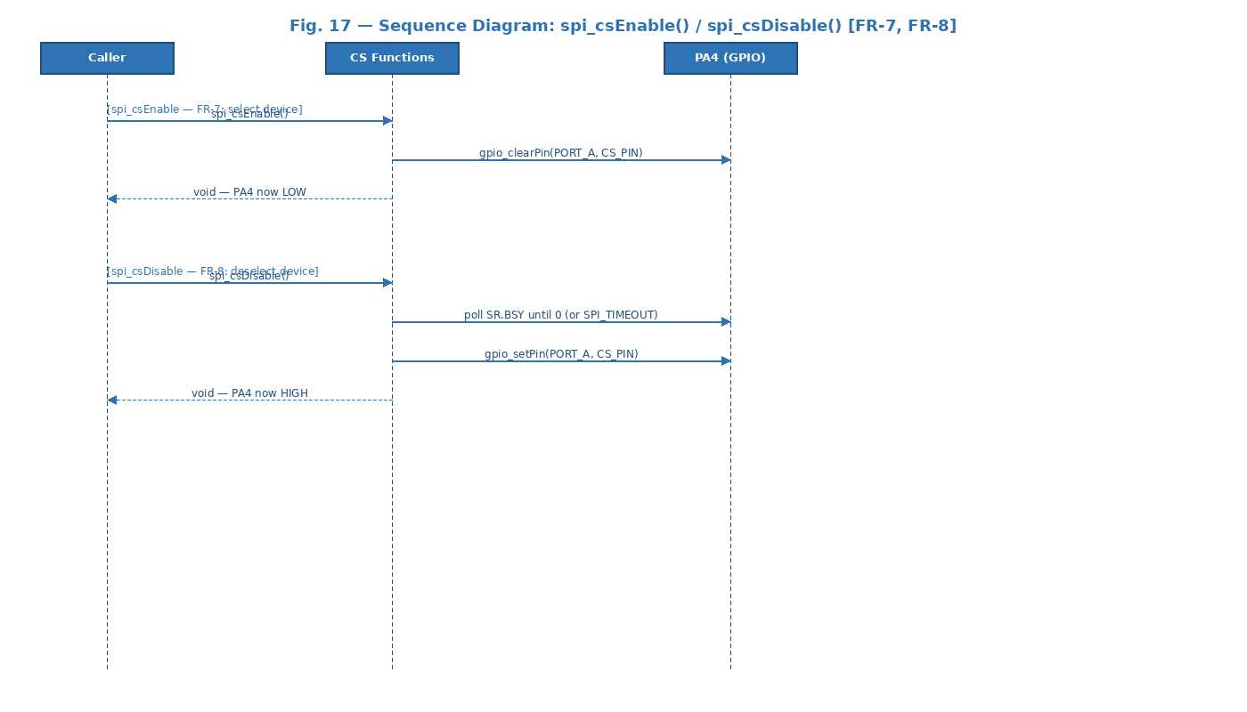
Fig. 17 — Sequence Diagram: csEnable clears PA4 immediately. csDisable polls BSY before setting PA4 HIGH.
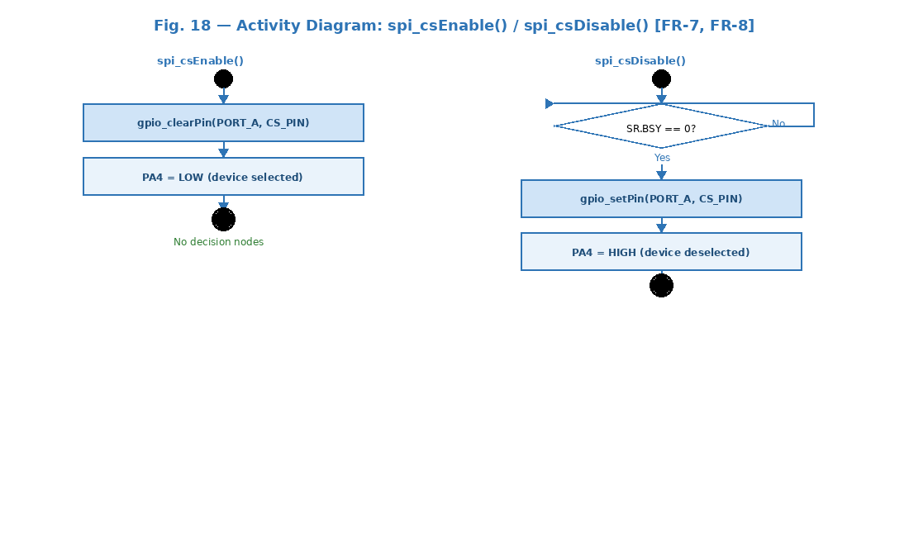
Fig. 18 — Activity Diagram: csEnable has no decision node. csDisable has a BSY polling loop.

3.3. SPI Driver — Internal Design

Internal Data Structures
The driver exposes no mutable global state. All hardware state is in SPI1 peripheral registers. Four private helpers encapsulate all register-level operations:
- prv_wait_sr(mask) — Polls SR until the masked flag(s) are set, SPI_TIMEOUT expires, or SPI_ERROR_FLAGS (OVR|MODF|CRCERR) detected. Returns 1 on success, 0 on timeout/error. Satisfies NFR-3.
- prv_has_error() — Reads SR, checks SPI_ERROR_FLAGS, clears them (OVR: read DR+SR; MODF: read SR+write CR1; CRCERR: write 0). Returns 1 if any error was set.
- prv_check_bus() — Returns SPI_OK if SR.BSY=0. Waits up to SPI_TIMEOUT cycles; returns SPI_BUSY if BSY persists.
- prv_transfer_byte(byte, rx) — Core primitive: waits TXE, writes byte to *(uint8_t*)&DR (8-bit write prevents 16-bit frame), waits RXNE, reads *(uint8_t*)&DR. If rx!=NULL stores received byte. Checks prv_has_error() after exchange.

Full-Duplex Exchange Principle
SPI is inherently full-duplex: for every byte sent on MOSI, one byte is received on MISO simultaneously. prv_transfer_byte() exploits this by always reading DR after TXE+write+RXNE — even during transmit (where the received byte is discarded by passing rx=NULL) and during receive (where the MOSI byte is 0x00 to generate the clock without meaningful data).
The 8-bit DR access uses *(uint8_t*)&DR instead of a simple SPI1->DR = byte assignment. This is required when the SPI data frame is 8-bit (DFF=0) — a 32-bit write to DR would cause a 16-bit transfer on some STM32 compilers. The volatile cast ensures the compiler generates an 8-bit STRB instruction (RM0383 requirement).

CS Timing
spi_csDisable() waits for SR.BSY before driving PA4 HIGH. BSY is cleared by hardware only after the last bit has been shifted out of the shift register — not just after DR is empty (TXE). Without this wait, the CS falling edge could truncate the last byte on the MOSI line, causing the slave to receive an incomplete transaction.

Error Handling
Validate-before-access: NULL and len=0 checks precede any hardware register write (NFR-2). OVR, MODF, and CRCERR are detected by prv_wait_sr() and prv_has_error() and cleared atomically. SPI_TIMEOUT bounds all polling loops (NFR-3). Error codes: SPI_OK=0, SPI_ERR=1, SPI_BUSY=2.

4. Application Programming Interfaces

4.1. Data Types and Macros
- SPI_Status_t: SPI_OK=0, SPI_ERR=1, SPI_BUSY=2.
- SPI_CR1_BR_DIV8: (0x2U<<3U) — Baud rate prescaler bits for fPCLK/8 (~2 MHz from 16 MHz APB2). Suitable for ADXL345 (max 5 MHz).
- SPI_TIMEOUT: 160000 cycles (~10 ms at 16 MHz).
- SPI_ERROR_FLAGS: SPI_SR_OVR | SPI_SR_MODF | SPI_SR_CRCERR — mask for all hardware error flags in SR.

Register | Offset | Access | Used by Function(s) | Purpose in Driver
RCC->AHB1ENR | 0x40023830 | R/W | spi_init() | Enable GPIOA clock (bit 0).
RCC->APB2ENR | 0x40023844 | R/W | spi_init() | Enable SPI1 clock (bit 12).
SPI1->CR1 | 0x40013000 | R/W | spi_init() | SPE, MSTR, BR, CPOL, CPHA, SSM, SSI, DFF, LSBFIRST bits.
SPI1->CR2 | 0x40013004 | R/W | spi_init() | Set to 0: SSOE=0 (manual CS), no DMA, no interrupts.
SPI1->SR | 0x40013008 | R/W | prv_wait_sr, prv_has_error, prv_check_bus, spi_csDisable | TXE(1), RXNE(0), BSY(7), OVR(6), MODF(5), CRCERR(4) flags.
SPI1->DR | 0x4001300C | R/W | prv_transfer_byte | 8-bit access: write starts MOSI shift; read returns MISO byte.

4.2. Error Codes
Code | Value | Returned By | Trigger Condition
SPI_OK | 0 | spi_transmit(), spi_receive() | All bytes exchanged successfully.
SPI_ERR | 1 | spi_transmit(), spi_receive() | NULL buffer, len==0, TXE/RXNE timeout, or OVR/MODF/CRCERR detected.
SPI_BUSY | 2 | spi_transmit(), spi_receive() | SR.BSY did not clear within SPI_TIMEOUT cycles.

4.3. Function Definitions

spi_init
Function Name | spi_init
Syntax | void spi_init(void)
Parameters (in) | N/A
Parameters (inout) | N/A
Parameters (out) | N/A
Return value | void — Always succeeds.
Description | Initializes SPI1 in Master Mode, Mode 0 (CPOL=0, CPHA=0), 8-bit, MSB first, fPCLK/8 (FR-1, FR-2). Enables RCC clocks, configures PA5/PA6/PA7 as AF5 push-pull, PA4 as GPIO output with CS=HIGH, writes CR1/CR2, enables SPE.
Constraints | Must be called before any transaction. PA4-PA7 must not be used for other functions before this call.
Available via | spi_driver.h

spi_transmit
Function Name | spi_transmit
Syntax | SPI_Status_t spi_transmit(const uint8_t *data, uint32_t len)
Parameters (in) | data — const uint8_t*: transmit buffer (non-NULL). len — uint32_t: byte count (>0).
Parameters (inout) | N/A
Parameters (out) | N/A
Return value | SPI_OK / SPI_ERR / SPI_BUSY
Description | Sends len bytes over SPI (FR-3, FR-4). Validates args, checks BSY, then for each byte calls prv_transfer_byte(data[i], NULL) — TXE wait, 8-bit DR write, RXNE wait, discard received byte, error check.
Constraints | CS must be asserted by caller before and released after. OVR causes SPI_ERR; re-init may be required.
Available via | spi_driver.h

spi_receive
Function Name | spi_receive
Syntax | SPI_Status_t spi_receive(uint8_t *data, uint32_t len)
Parameters (in) | data — uint8_t*: receive buffer (non-NULL). len — uint32_t: byte count (>0).
Parameters (inout) | N/A
Parameters (out) | data — filled with len bytes received from slave.
Return value | SPI_OK / SPI_ERR / SPI_BUSY
Description | Receives len bytes over SPI (FR-5, FR-6). For each byte calls prv_transfer_byte(0x00, &data[i]) — sends dummy 0x00 to drive SCK, captures MISO into data[i].
Constraints | CS must be asserted by caller. The 0x00 dummy byte is sent on MOSI during reception; slave must tolerate this.
Available via | spi_driver.h

spi_csEnable
Function Name | spi_csEnable
Syntax | void spi_csEnable(void)
Parameters (in) | N/A
Parameters (inout) | N/A
Parameters (out) | N/A
Return value | void — No return value.
Description | Drives CS line LOW via gpio_clearPin(SPI_CS_PORT, SPI_CS_PIN) to select the target device (FR-7). Must be called before spi_transmit() or spi_receive().
Constraints | No error checking — assumes GPIO was initialized by spi_init(). Must be paired with spi_csDisable() after the transaction.
Available via | spi_driver.h

spi_csDisable
Function Name | spi_csDisable
Syntax | void spi_csDisable(void)
Parameters (in) | N/A
Parameters (inout) | N/A
Parameters (out) | N/A
Return value | void — No return value.
Description | Waits for SR.BSY to clear (up to SPI_TIMEOUT cycles) then drives CS HIGH via gpio_setPin() (FR-8). BSY wait ensures last bit is fully shifted out before CS rises.
Constraints | Must be called after the transaction is complete. If BSY never clears (peripheral stuck), CS is released anyway after timeout — call spi_init() to recover.
Available via | spi_driver.h

4.4. Internal Function Definitions

prv_wait_sr
Function Name | prv_wait_sr
Syntax | static uint8_t prv_wait_sr(uint32_t mask)
Parameters (in) | mask — uint32_t: SR flag(s) to wait for (SPI_SR_TXE or SPI_SR_RXNE).
Return value | 1 if flag(s) set within timeout; 0 on SPI_TIMEOUT expiry or SPI_ERROR_FLAGS detected.
Description | Central flag-polling helper with bounded wait (NFR-3). Exits early on OVR/MODF/CRCERR.
Constraints | Static in spi_driver.c. Not in public API. Must not be called with SPE=0.

prv_has_error
Function Name | prv_has_error
Syntax | static uint8_t prv_has_error(void)
Parameters (in) | N/A
Return value | 1 if OVR, MODF, or CRCERR was set (and cleared); 0 if no errors.
Description | Reads SR, checks SPI_ERROR_FLAGS, clears each per RM0383: OVR — read DR then SR; MODF — read SR then write CR1; CRCERR — write 0 to bit.
Constraints | Static in spi_driver.c. Called by prv_transfer_byte() after every byte exchange.

prv_check_bus
Function Name | prv_check_bus
Syntax | static SPI_Status_t prv_check_bus(void)
Parameters (in) | N/A
Return value | SPI_OK if SR.BSY=0 within timeout; SPI_BUSY otherwise.
Description | Verifies bus is idle before starting a transaction. Called as first hardware check in spi_transmit() and spi_receive().
Constraints | Static in spi_driver.c. Does not reset the peripheral on timeout.

prv_transfer_byte
Function Name | prv_transfer_byte
Syntax | static SPI_Status_t prv_transfer_byte(uint8_t byte, uint8_t *rx)
Parameters (in) | byte — uint8_t: byte to transmit on MOSI. rx — uint8_t*: pointer to store received MISO byte; if NULL, received byte is discarded.
Return value | SPI_OK on successful exchange; SPI_ERR on TXE/RXNE timeout or hardware error.
Description | Core full-duplex primitive. Waits TXE, writes byte via *(uint8_t*)&DR (8-bit STRB), waits RXNE, reads *(uint8_t*)&DR. If rx!=NULL stores received byte. Calls prv_has_error() after exchange.
Constraints | Static in spi_driver.c. 8-bit DR access mandatory for DFF=0 (RM0383). Never called before prv_check_bus() in public functions.

5. Future Enhancements
- DMA support: spi_transmit_DMA() and spi_receive_DMA() using SPI TX/RX DMA requests for zero-CPU-overhead bulk transfers.
- Interrupt-driven transfers: SPI RXNE/TXE interrupt handlers to free the CPU during transfers, enabling concurrent processing.
- 16-bit data frame: Parameterize prv_transfer_byte() for DFF=1 (16-bit) transfers for displays and ADCs that use 16-bit SPI words.
- Multiple CS lines: Extend spi_csEnable()/spi_csDisable() to accept a device index parameter for multi-device SPI bus management.
- Configurable clock speed: Parameterize spi_init() to compute BR bits from a target frequency and APB2 clock, supporting rates from fPCLK/2 to fPCLK/256.

